1. Your application should be able to add roles in the database dynamically.

Postman Results: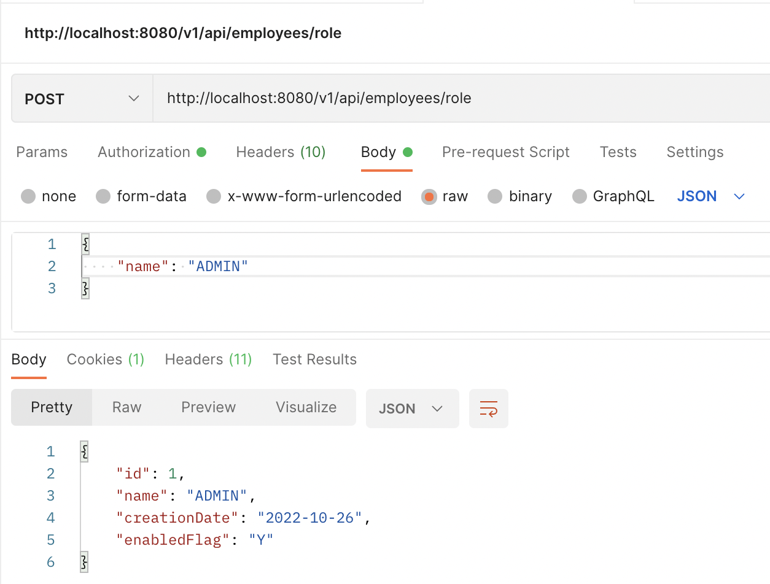

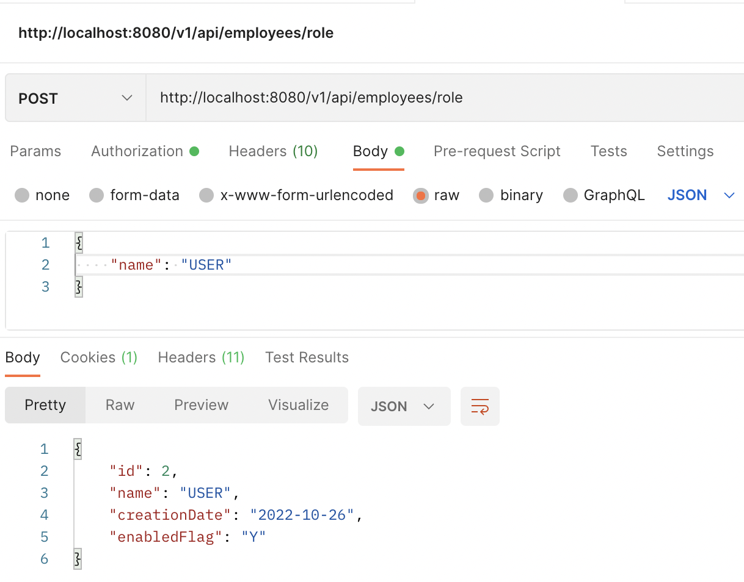

H2 database:

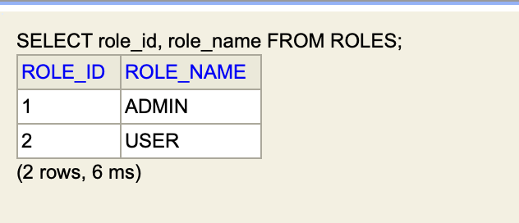

1. Your application should be able to add Users in the db which can be used for authentication purposes.

Postman Results: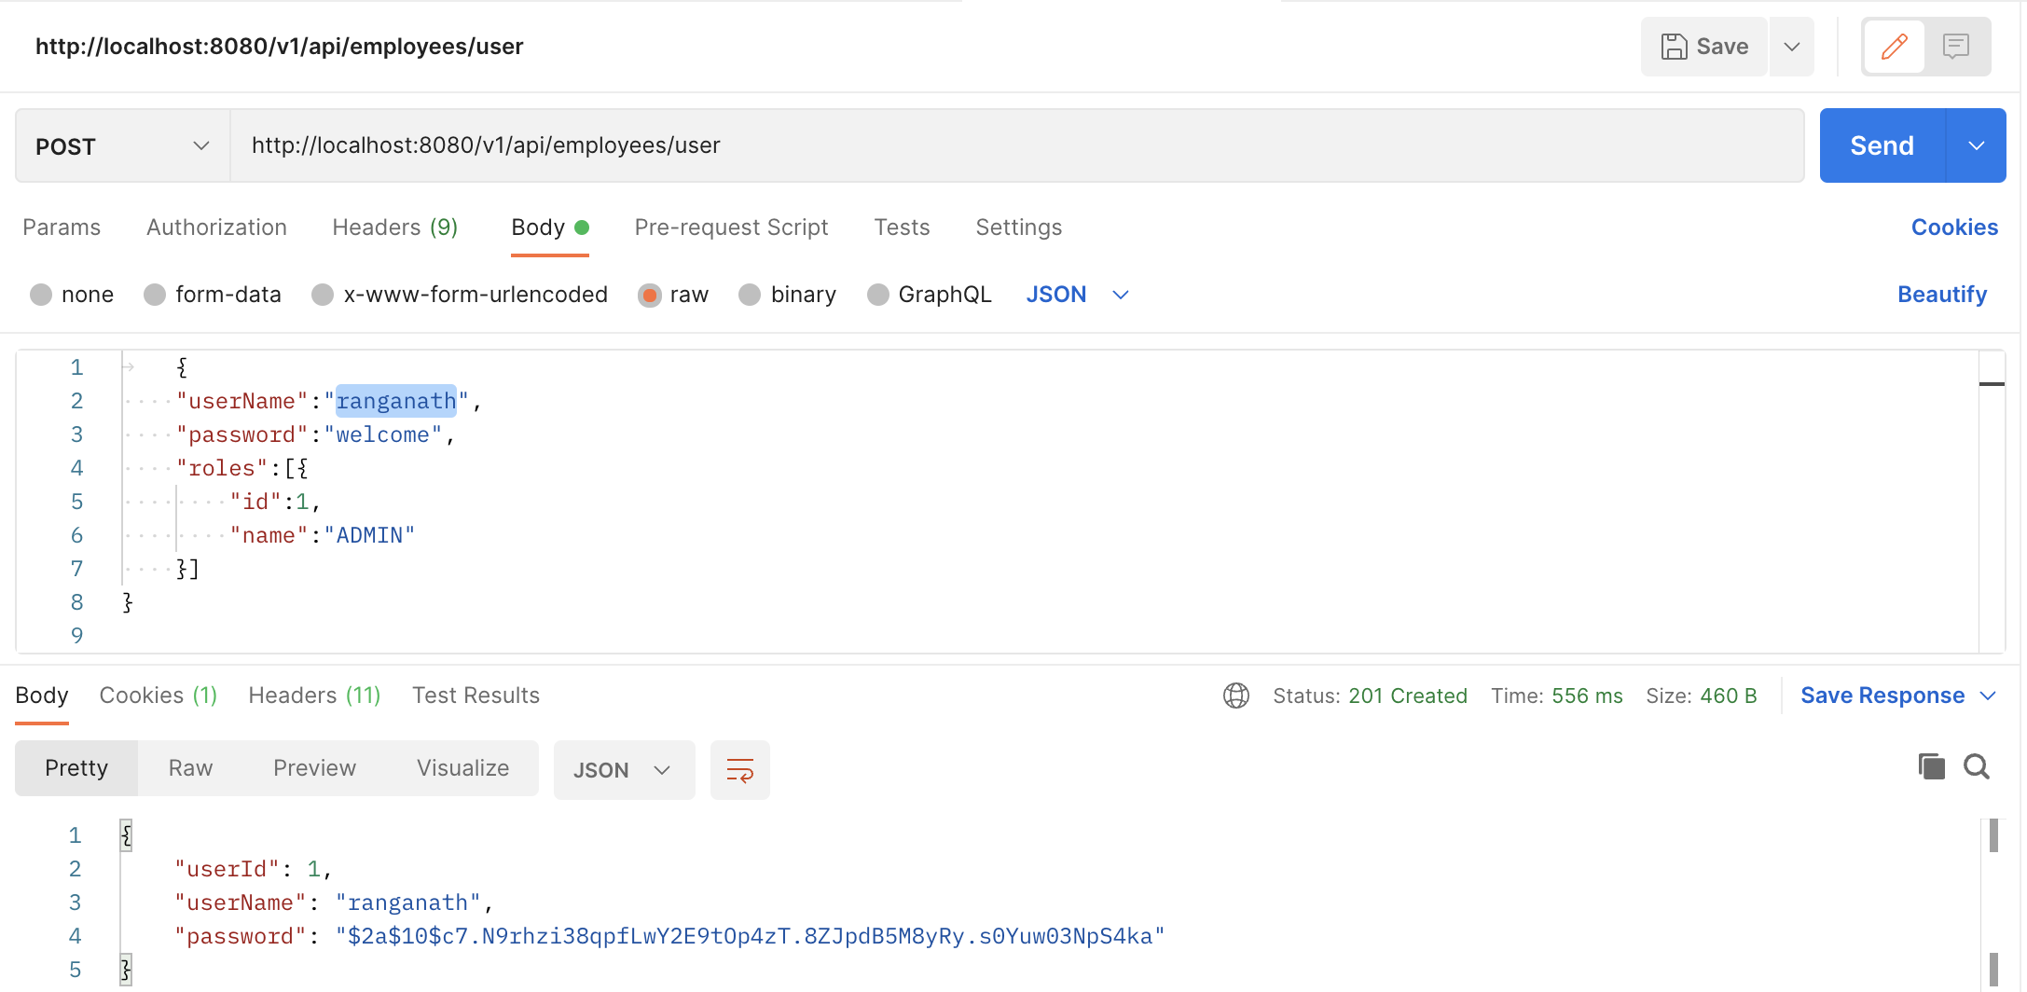

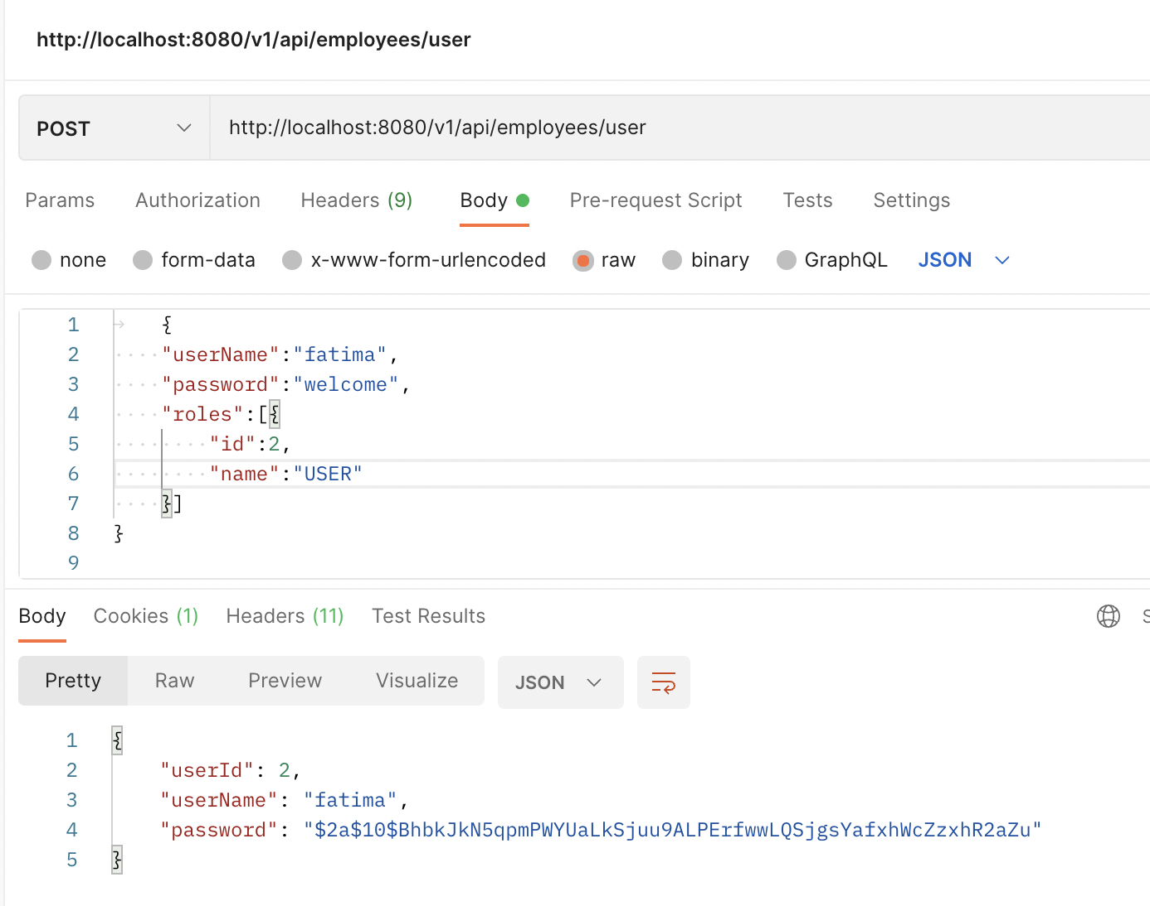

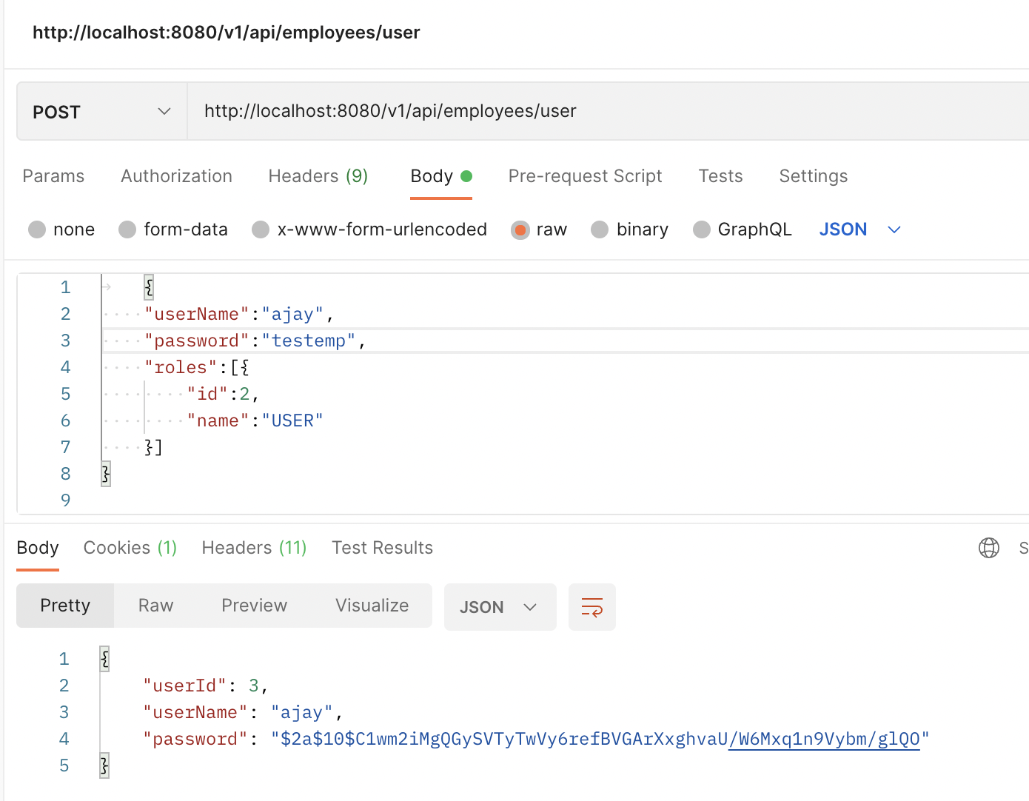

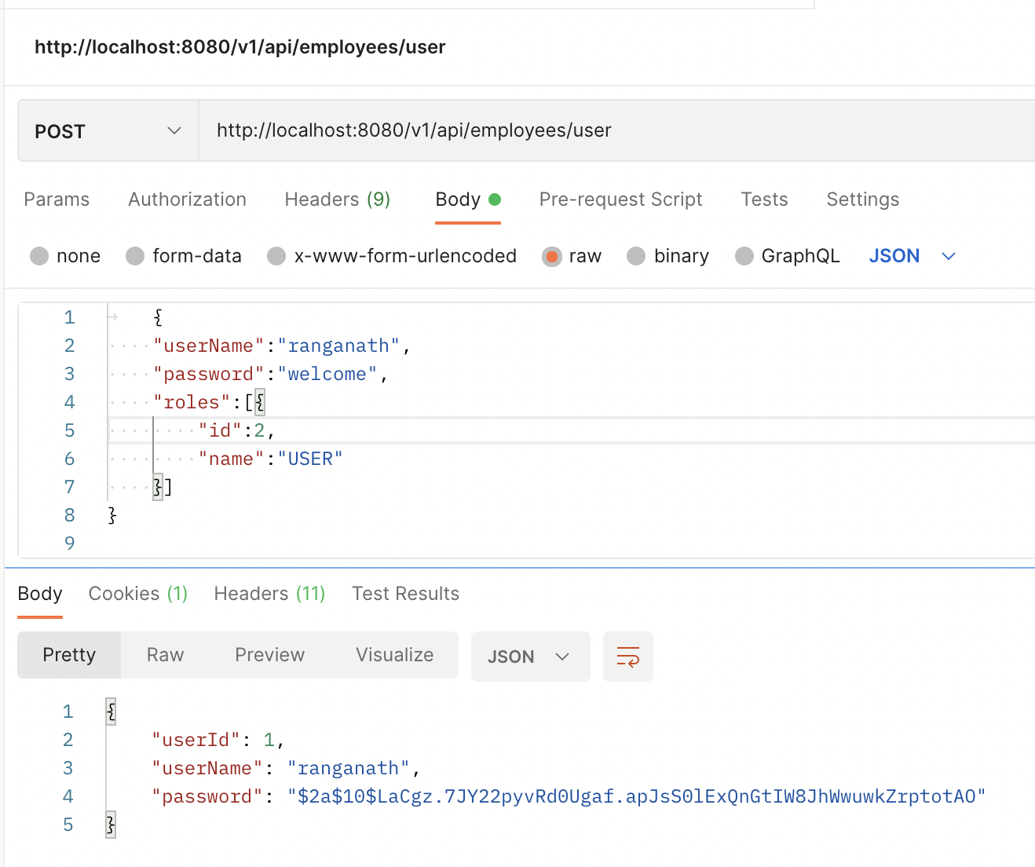

H2 Database:

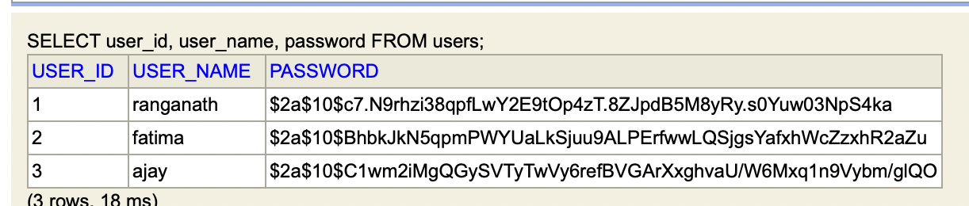

Entity relation mapping between users and roles:

H2 Database:

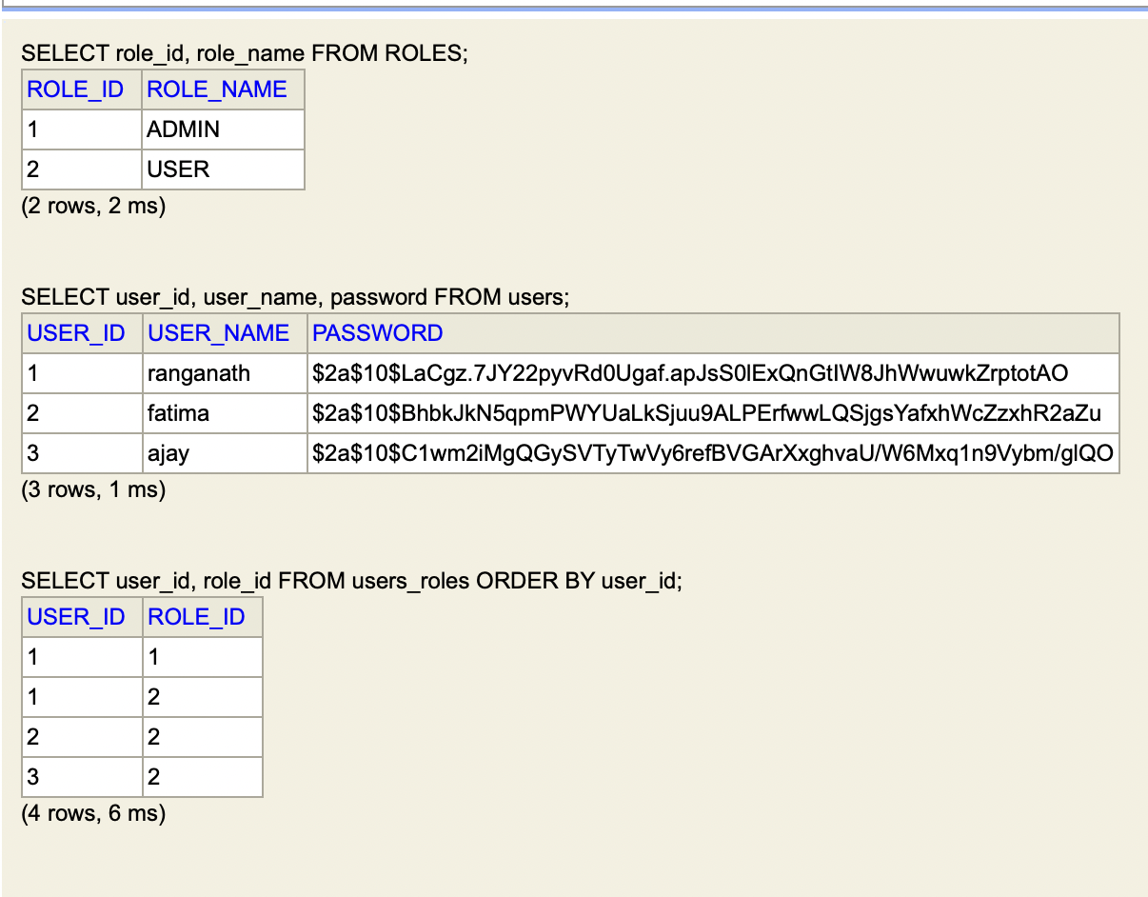

1. Now Your application should be able to add employees data in the db if and only if the authenticated user is **ADMIN**-

Below are the user and role details in the H2 database.

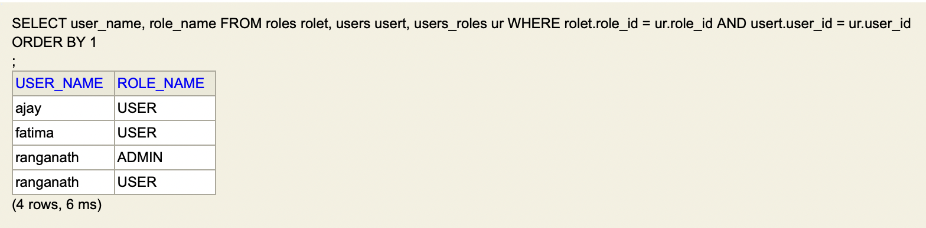

Postman Results:

Able to create the employee with user who has admin ROLE.

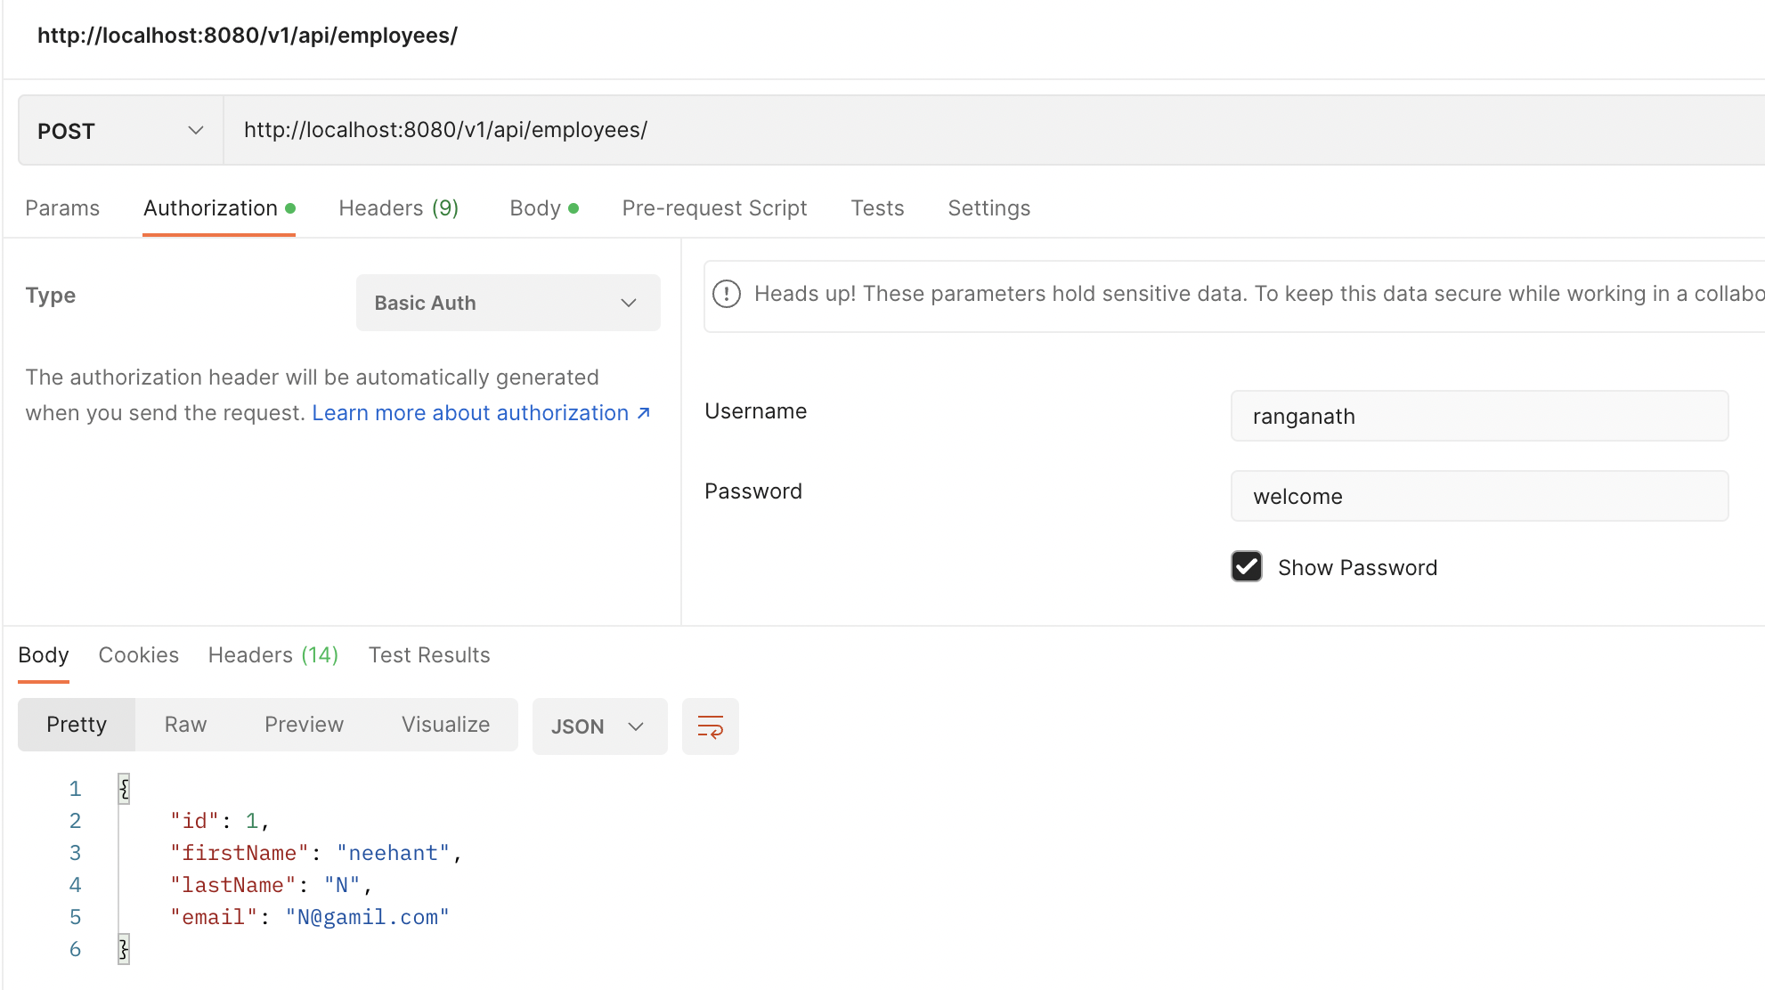

API does not allow the user to create an employee if they don’t have ADMIN role.

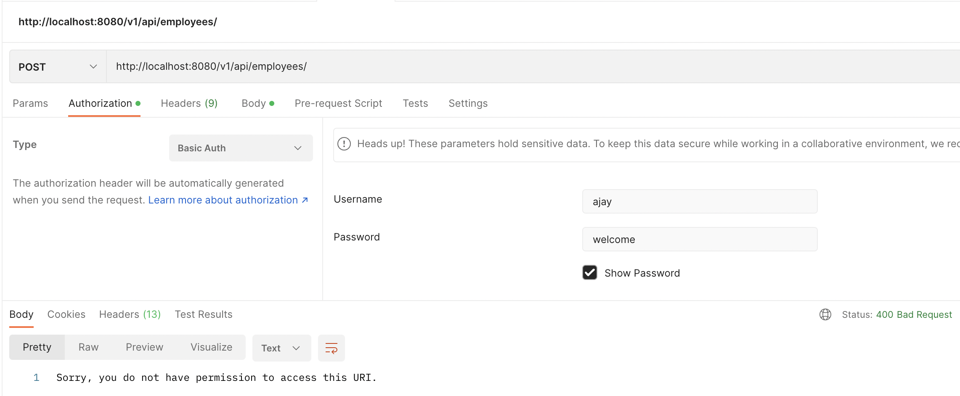

Created two more employee from user who has ADMIN role. Below are the details of all employees in H2 database.

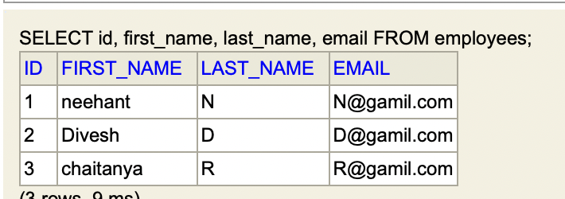

1. Your application should provide an endpoint to list all the employees stored in the database.

Postman Results:

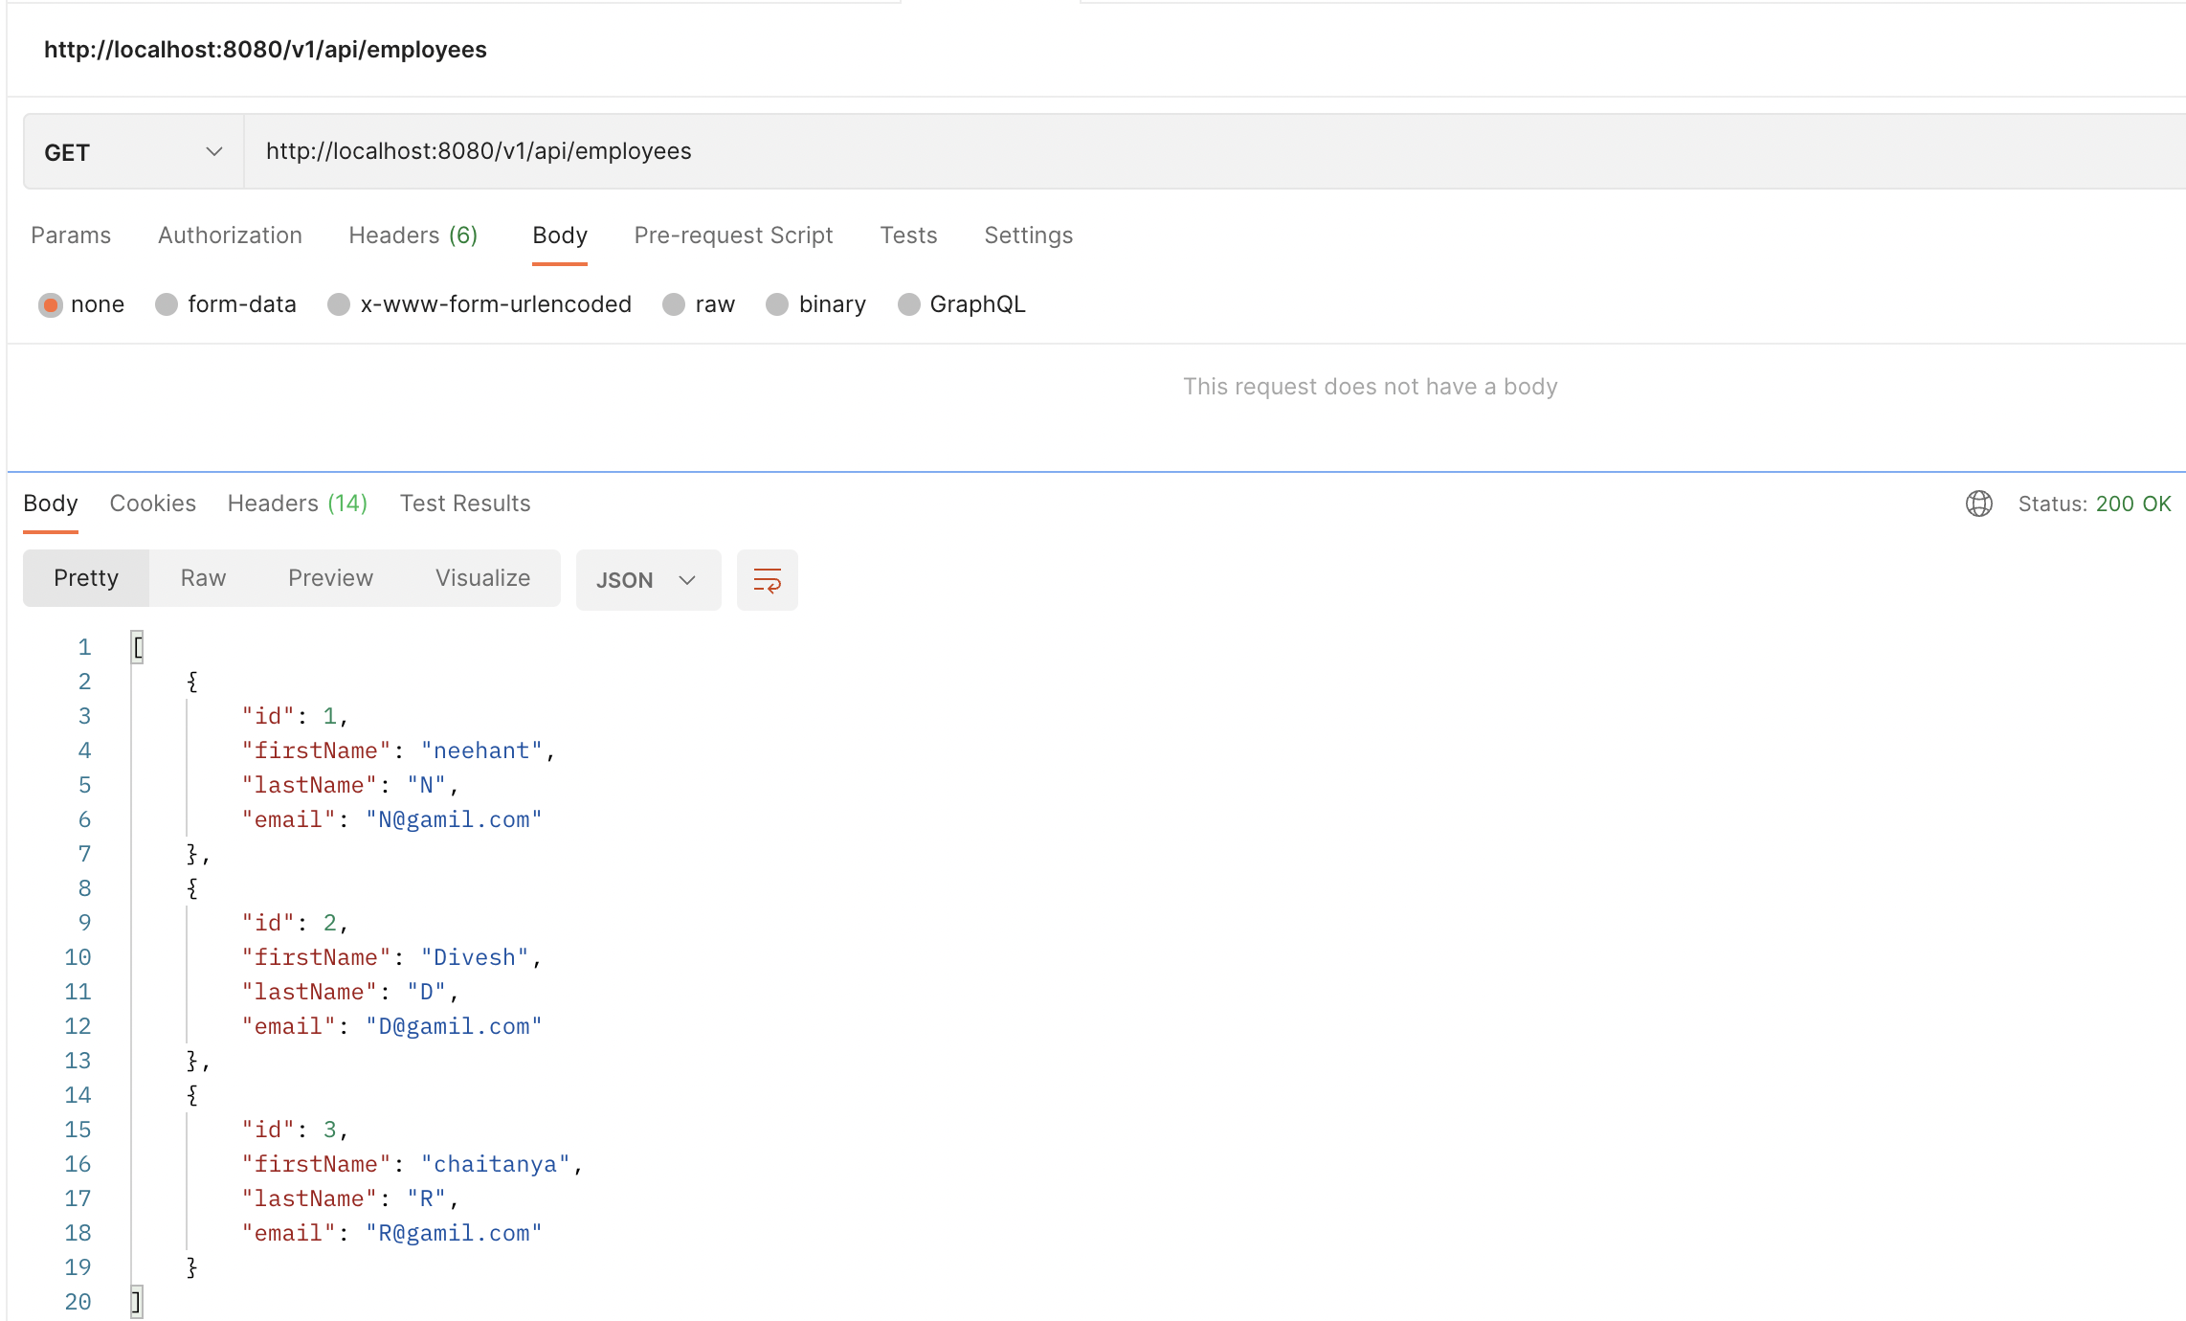

1. Your application should provide endpoint to fetch or get an employee record specifically based on the id of that employee-

Postman Results:

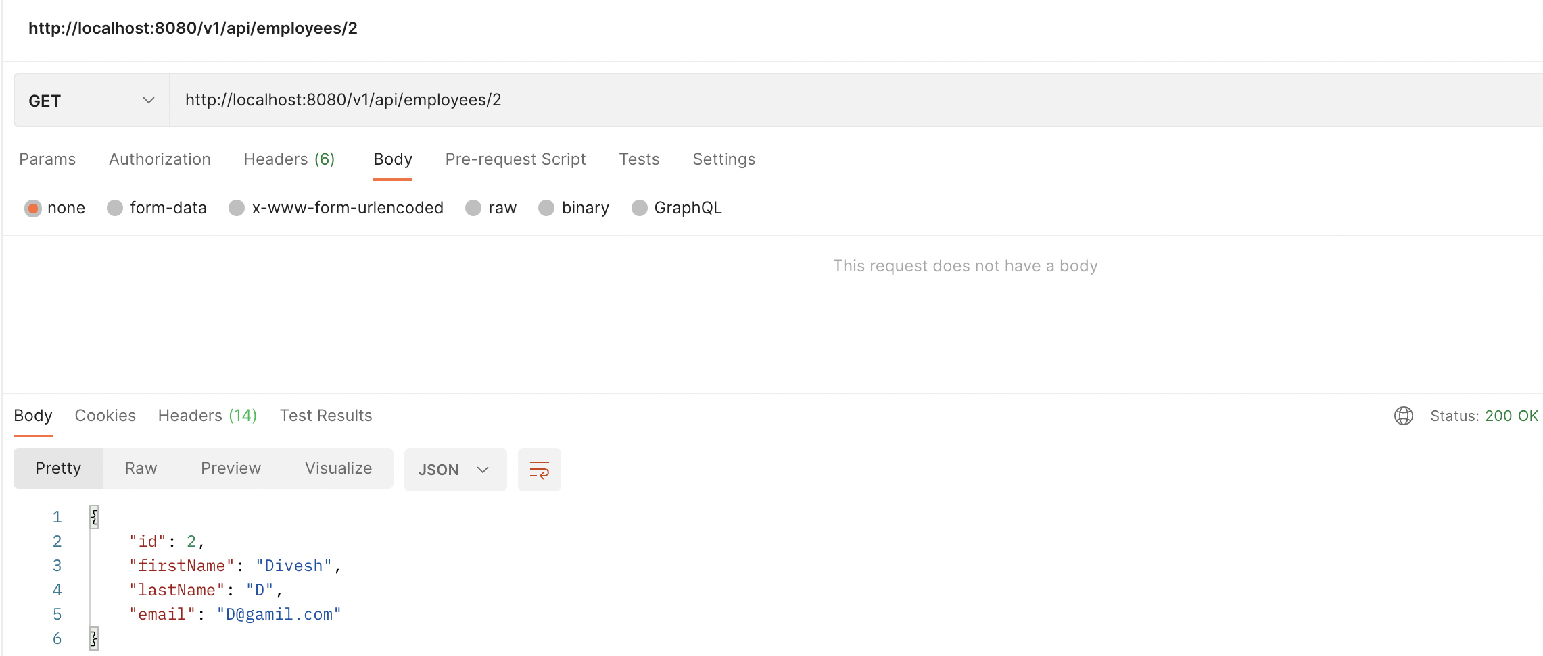

1. Your application should provide an endpoint to update an existing employee record with the given updated json object.

Employee details in H2 database before update:

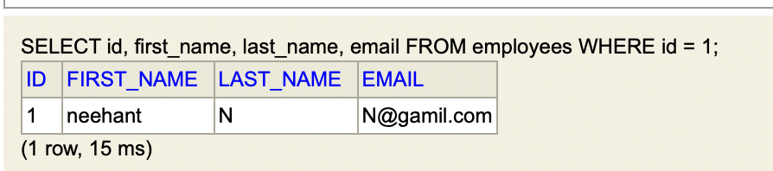

Postman Results:

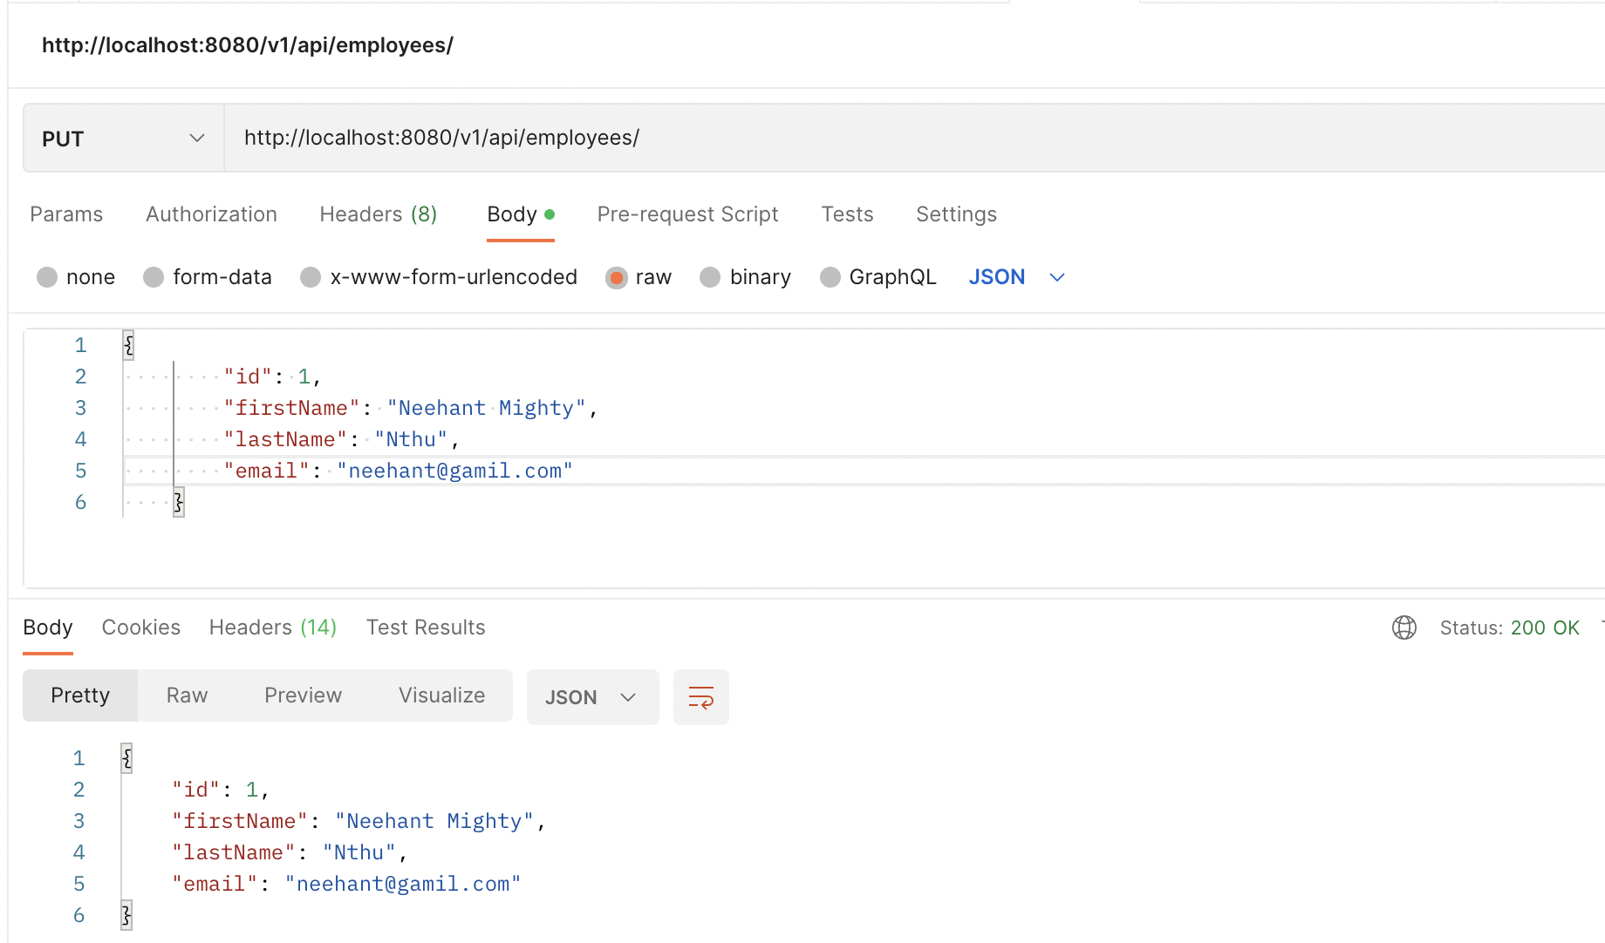

Employee details in H2 database after update:

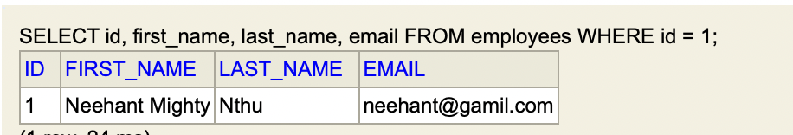

1. Your application should also provide an endpoint to delete an existing employee record based on the id of the employee-

Employee details in the H2 database before deletion

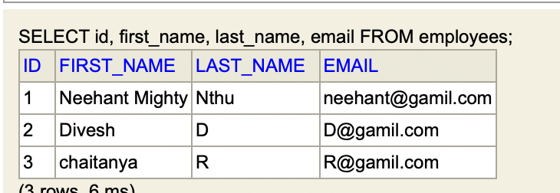

Postman Results:

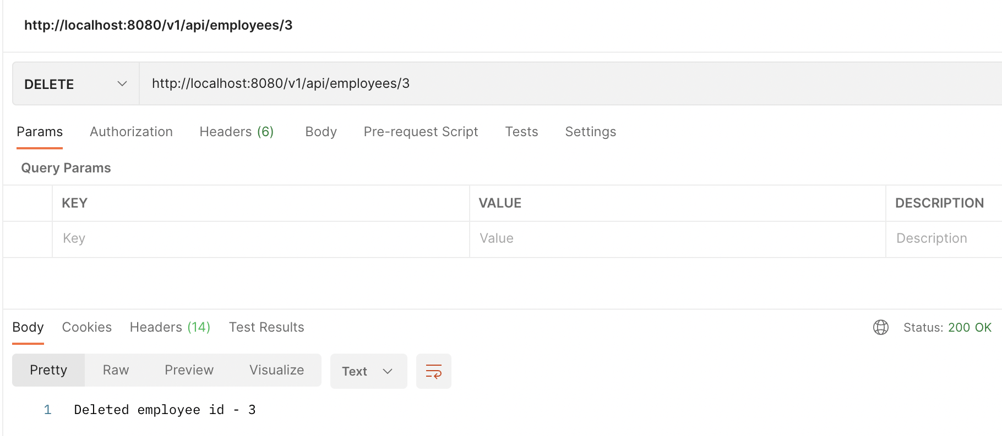

Employee details in the H2 database after deletion:

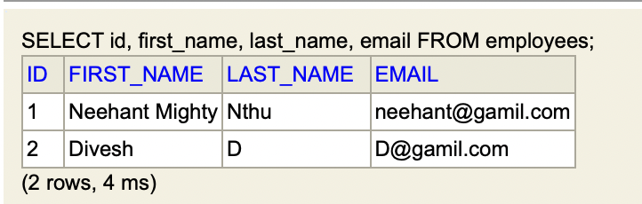

1. Your application should provide an endpoint to fetch an employee by his/her first name and if found more than one record then list them all-

Employee details in the H2 database



Postman Results:

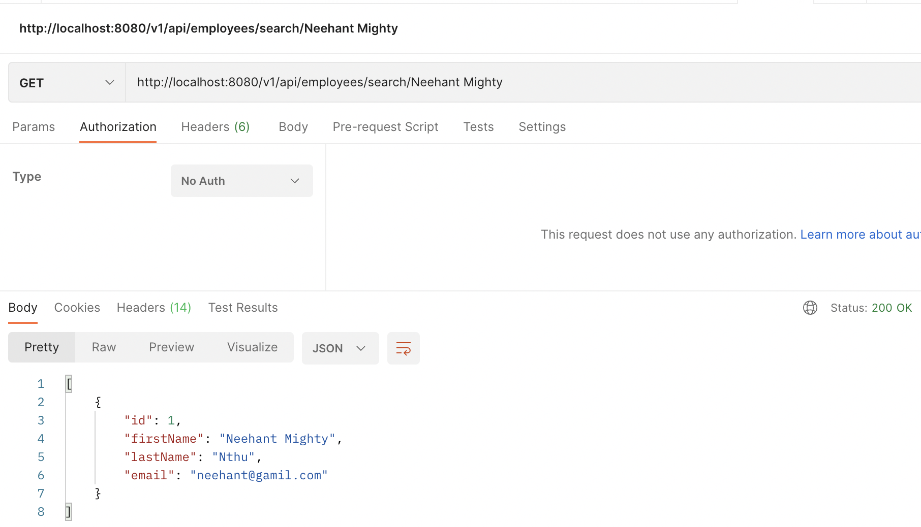

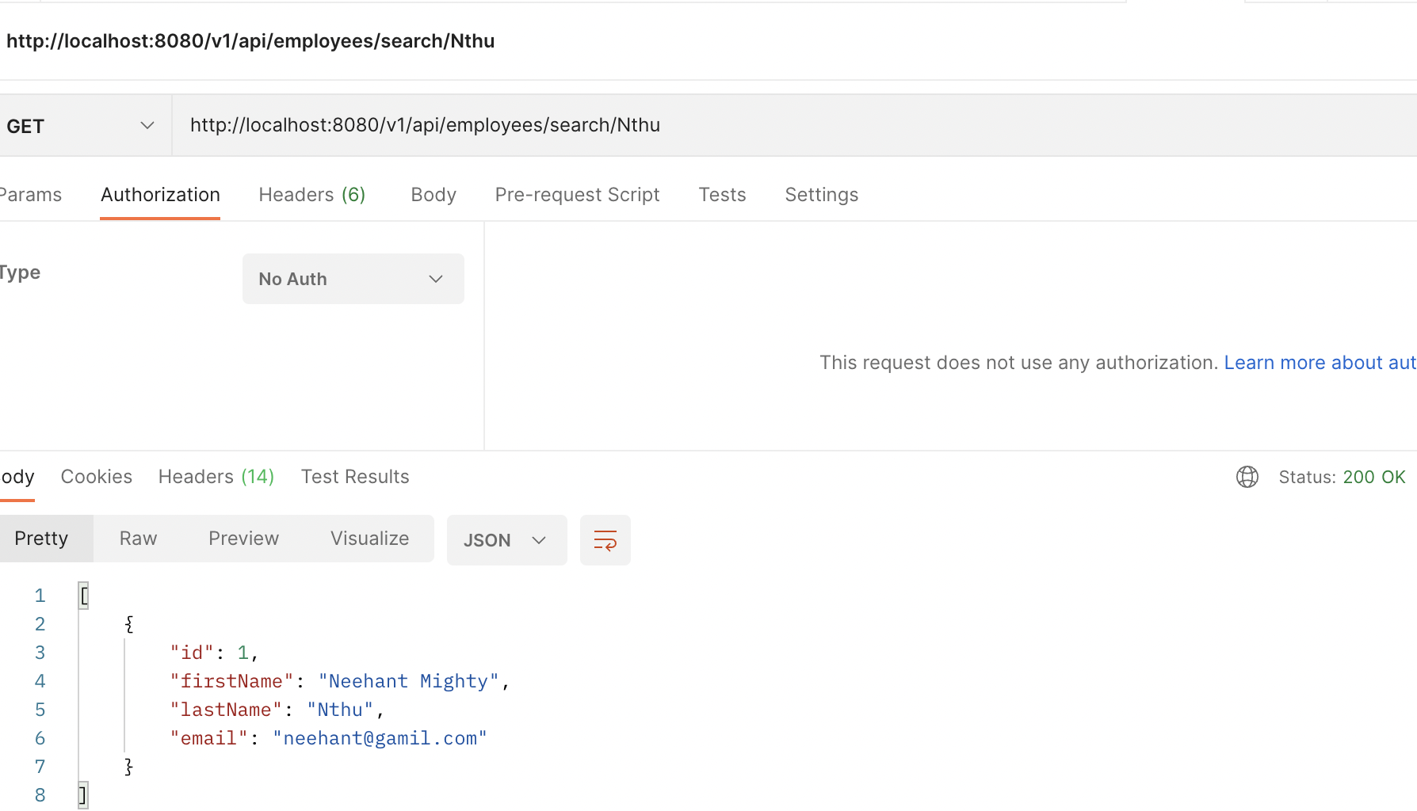

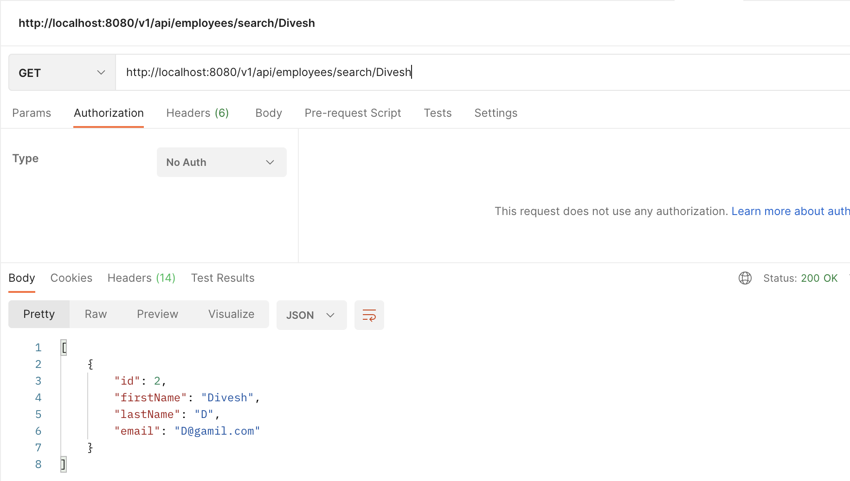

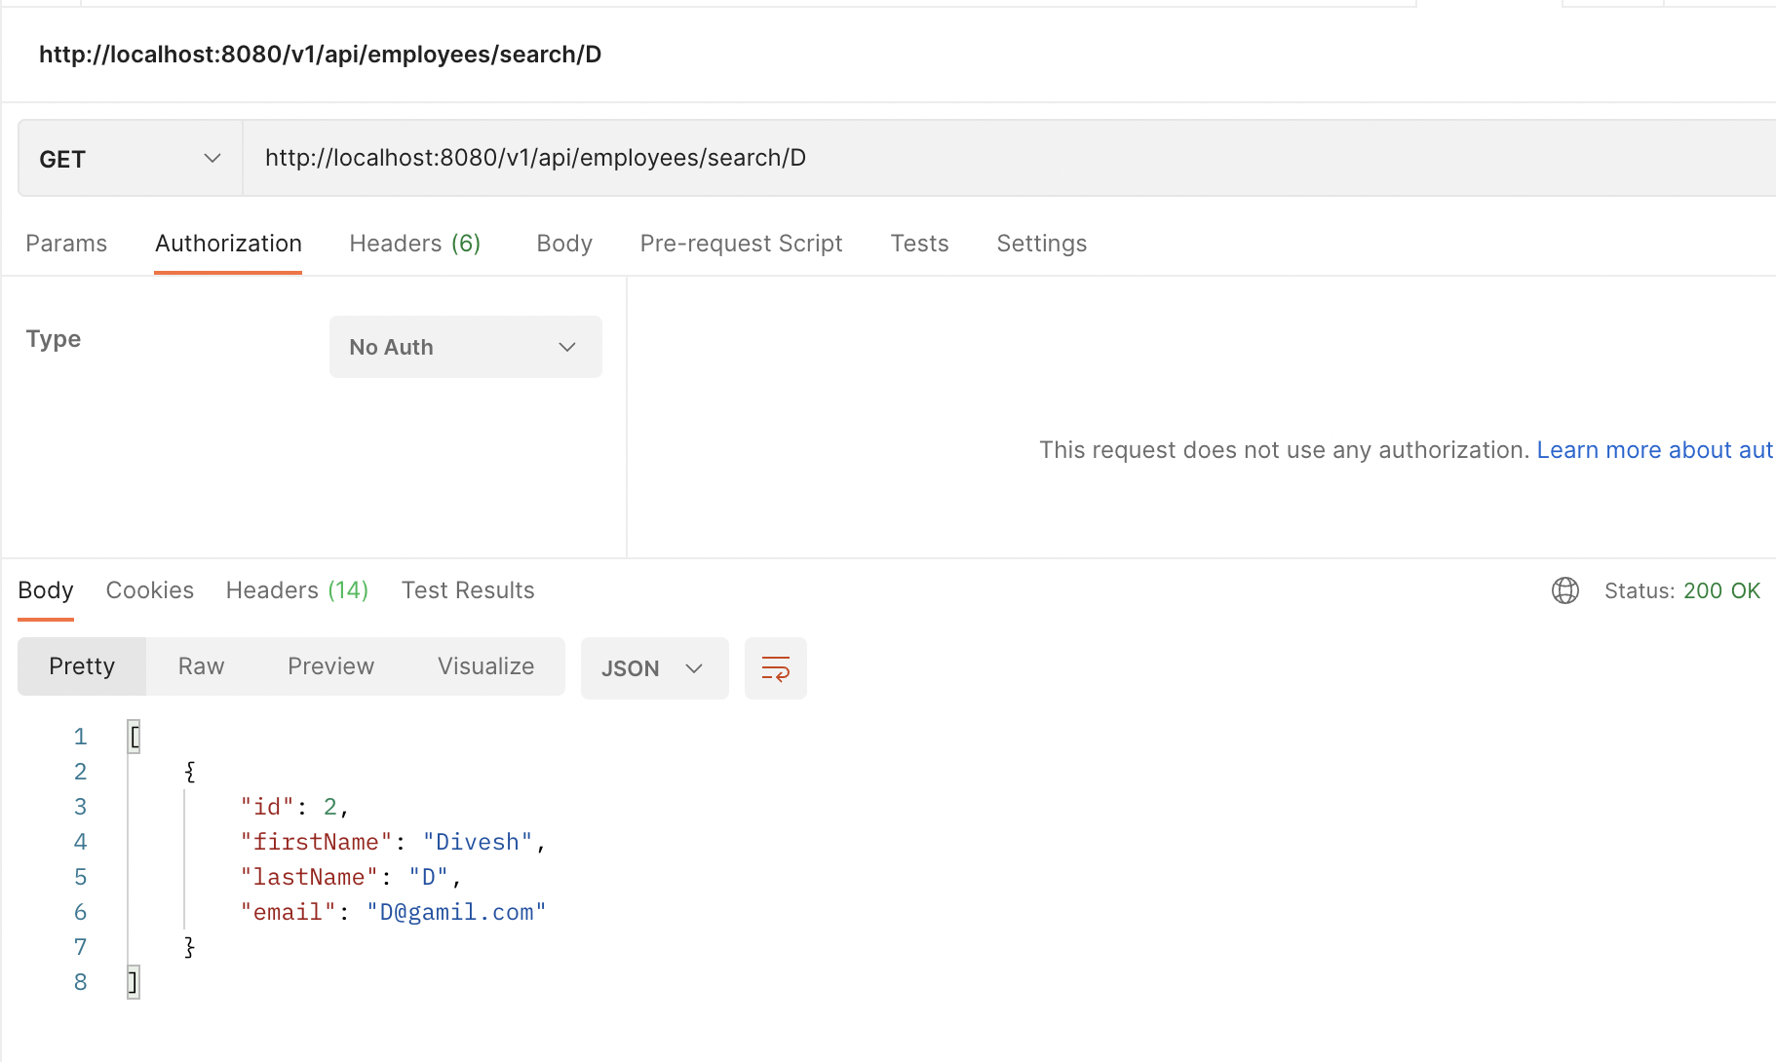

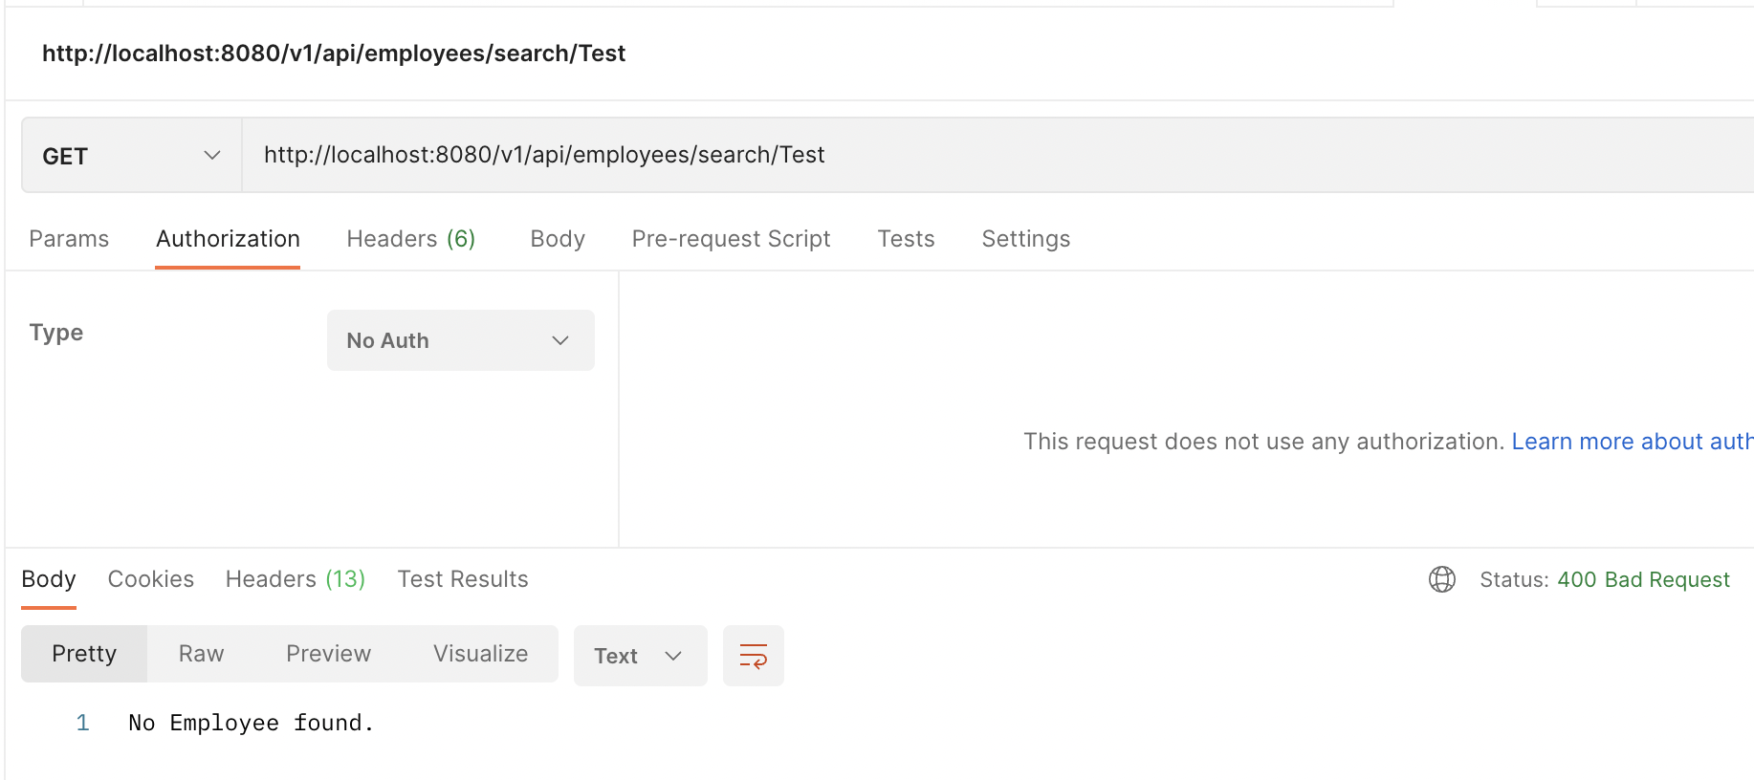

1. Your application should be able to list all employee records sorted on their first name in either ascending order or descending order .

Postman Results:

